Areesha Raheel
55039
BSIT-5
Cyber Security
Lab Task 01:
Basic Commands :
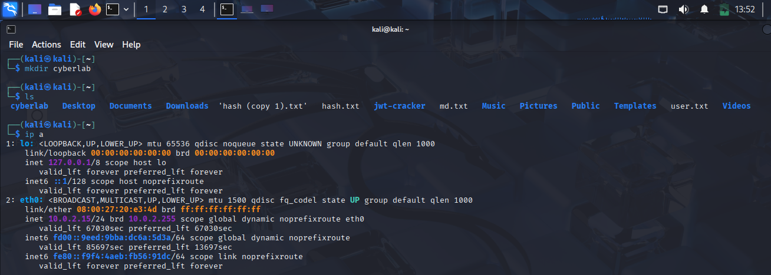
Net-Tools Install:
